PROFILE  Cody Hall – lead vocals, guitar  Jacqueline Kennelly – lead guitar  Erik Trotter - drums  Dusty Litchfield - bass  CONTACT  PHONE:  403-394-5758  WEBSITE:  www.codyhallmusic.com  EMAIL:  thecodyhallband@gmail.com  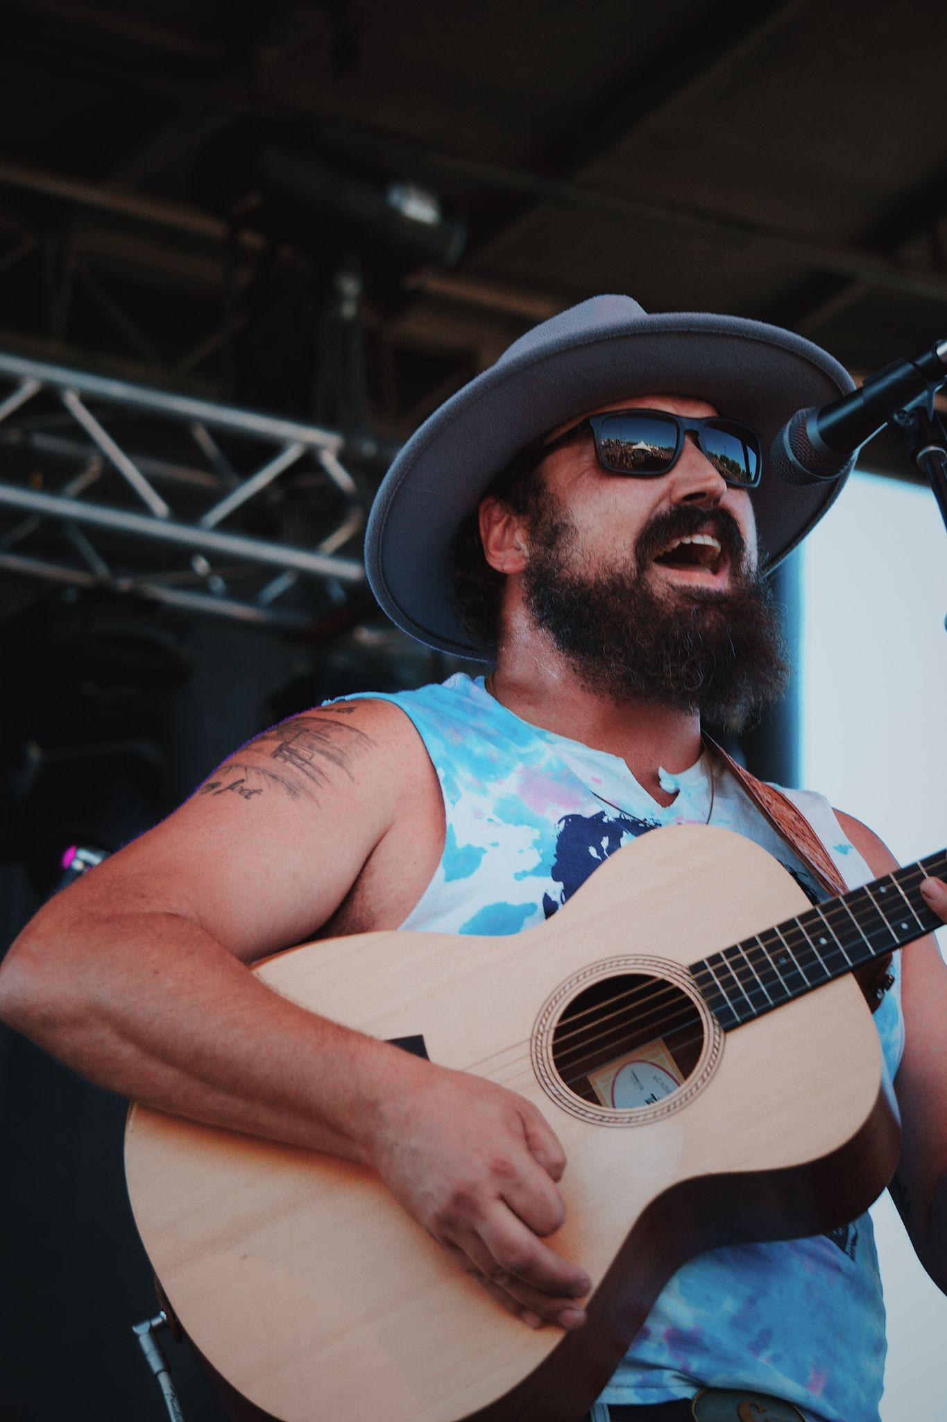 |  | CODY HALL  WHO WE ARE:  Hailing from the vibrant music scene of Lethbridge, Alberta, Cody Hall is the epitome of alternative country energy. Fronted by Cody Hall on vocals and guitar, complemented by the talents of original member Jacqueline Kennelly on guitar, bassist Dusty Litchfield, and Erik Trotter on drums, Cody Hall has been making waves since their inception in 2017.  Cody Hall is celebrated for their dynamic live performances that fuse together elements of country, rock, and alternative music, creating a sound that is uniquely their own. Each show is a testament to their passion for music and dedication to delivering an unforgettable experience to their audience.  With a seamless blend of genres and a magnetic stage presence, Cody Hall continues to captivate audiences with their infectious rhythms and heartfelt lyrics.  PAST SHOWS  Music Festivals/Events  Country Thunder Alberta – Country 105 stage  Whoop up days - Original 16 stage  Stavely Indoor Pro Rodeo Cabaret  The Alpha Bull Chad Besplug Invitational Bull riding  Waynestock  PASSFest  Live Venues  Since forming in 2017 The Cody Hall Band has played live shows at different venues across Southern Alberta and into BC. Most notably at;  The King Eddy - Calgary,  The Ironwood Stage – Calgary  Tirbal Connection Market – Okotoks  Knee Deep – High River  The Stavely Hotel - Stavely  The Slice – Lethbridge  The Brick house – Fernie BC  The owl acoustic lounge - Lethbridge  The Mucky Duck pub - High River  Canadian Brewhouse - Lethbridge  Blowers and Grafton - Lethbridge  Two guys pizza - Lethbridge  Private Functions/Weddings  We provide packages of entertainment for various occasions including; weddings, fundraisers, markets etc. We can play to suit the needs of the event and can provide up to four hours of entertainment.  SHOW STYLES  - Solo Acoustic performance.  -Singer songwriter style  - Duo – Cody and Jaqueline perform with acoustic and electric guitar  - Upbeat coffee shop style  - Three piece - Cody, Jacqueline and Dusty  - upbeat, small venue  - Four piece – vocals, guitar, bass and drums  - Concert/Dance atmosphere
PRICING
Please contact thecodyhallband@gmail.com with “booking” in the subject line. Each show has it’s own distinct needs and preparation. Prices will vary.

STAGE PLOT & INPUTS
________________________________________________________

4 piece band - PDF link

3 piece band - PDF link

SHAREABLES
________________________________________________________

cody bio pic
2
3
4
band
band 2
logo

RIDERS
________________________________________________________

Hospitality and Catering - Cody Hall rider

